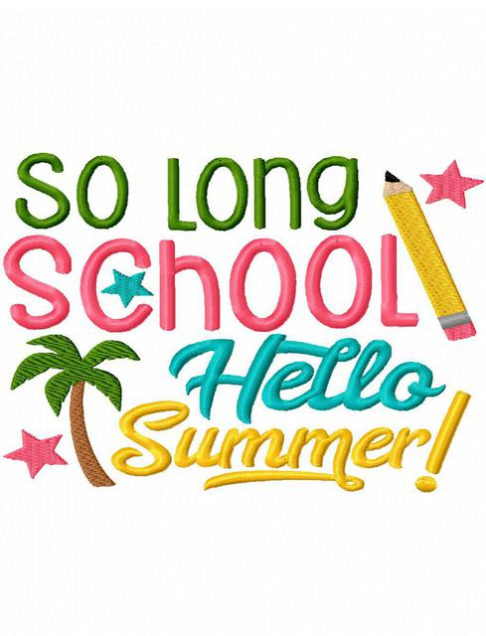
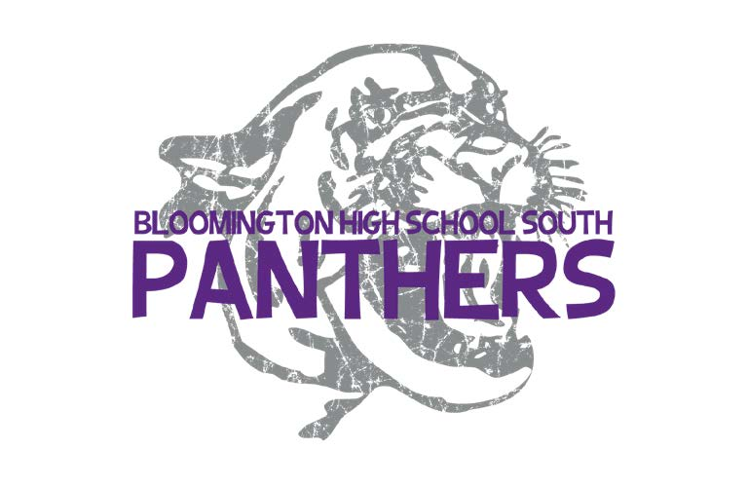
Summer 2022 BHSS FOOTBALL
PIZZA FUNDRAISER

Collect all money at the time of the sale.

Last day to turn in forms and money IN PERSON is on Wednesday May 11th. If submitting in person - checks may be made payable to BHSS QB Club.

Last day to turn in orders/money via email and Pay Pal- Friday May 13th.

Please email order form to Sophia Odulio at snodulio@gmail.com AND use Pay Pal on our website (click DONATE button on top right-hand side of Panther football home page) to turn in money collected

Designate all money turned in via the website as Summer Pizza Sale! http://www.bhsspantherfootball.com/

We need both the form emailed AND the money collected, please do BOTH.
Text/Call Sophia Odulio – 812.345.9066 or snodulio@gmail.com for questions

$12

Celebrate the start of summer while supporting Panther Football

Pizza Pickup Saturday May 21st 9a-12p
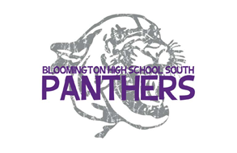
Player’s Name__________________________________________
Parent Contact Name____________________________________
Phone________________________________________________
Email_________________________________________________

NAME | PHONE | 14” CHEESE | 14” SAUSAGE | 14” PEPPERONI | 14”  COMBO (S/P) | TOTAL $ PAID
Total

